TYPES OF INTERACTIONS
Four ways that organisms interact are:
- competition
- cooperation
- predator and prey
- symbiosis
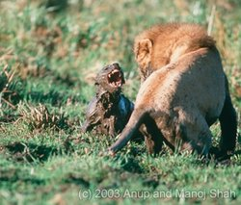

Competition: happens when organism need the same resources (food, water, shelter, space, sunlight). They all want to get their fair share. Ex: chimps and baboons

Cooperation: organisms work together toward a common goal. Ex: lions hunting together usually members of the same species(raising young, getting food)

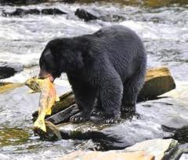

Consumer organisms need food. The food chain shows a predator-prey interaction. For survival, predators adapt in ways to catch their food. Organisms who are prey to predators adapt to keep from being caught. Ex: hawk/rabbit

