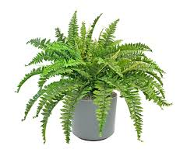
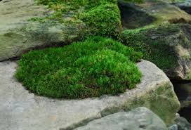
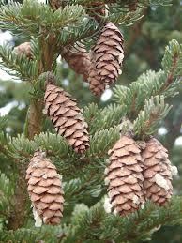

The Plant kingdom is in domain Eukarya

Characteristics:
- eukaryotic cells - have a nucleus
- multicellular
- heterotrophic - contain chlorophyll (pigment that absorbs light energy) in their chloroplast and do photosynthesis
- cuticle - waxy layer that coats the surface of stems, leaves, and other plant parts
- cell wall made of cellulose

Divisions(what they call Phlum for plants):
Mosses:
- nonvascular- without vessels to transport water and nutrients

- small

- live in wet areas

- no true stems, roots, and leaves

- reproduce by spores

Ferns:
- vascular - have tissues to deliver water and other materials throughout the plant

- reproduce by spores

Conifers:
- also called gymnosperms- “naked seed”
or seed not enclosed in a fruit

- vascular

- Examples: ginkgo tree, pine trees
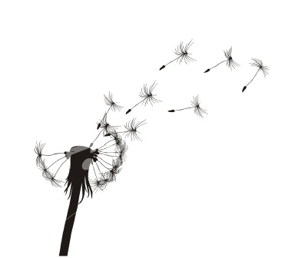
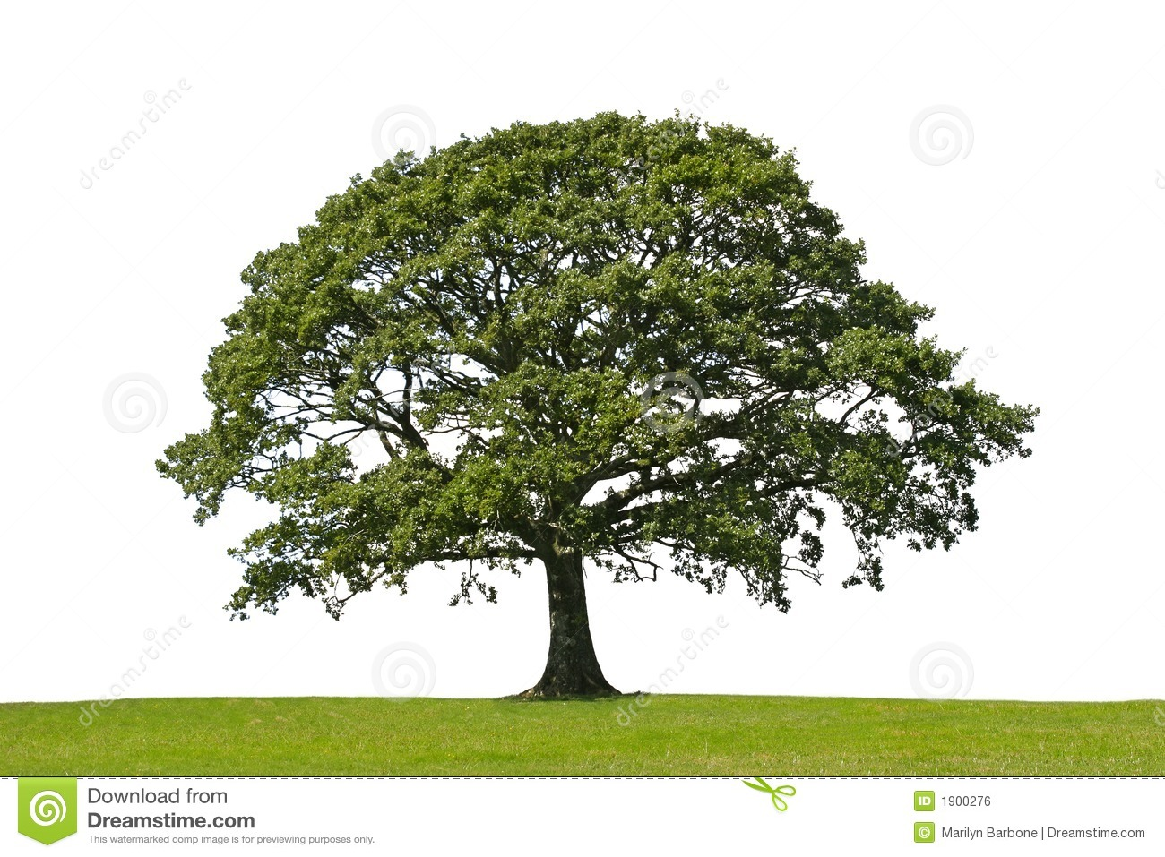
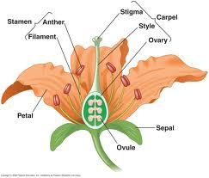
Flowering Plants:
- also called angiosperms - seed plant with flowers

- vascular

- fruit surround and protect seeds

- Examples: apples, corn, roses, eggplant, etc.

Plant Behavior

The stimulus is what causes an organism to respond.

● phototropism – plants response to light

● geotropism – plants respond to gravity

● thigmotropism – plants respond to touch

● hydrotropism– plants respond to water

Plant Processes

Photosynthesis: Label the equation for the process of photosynthesis below.

6 CO₂ + 6 H₂O --------------> C₆H₁₂O₆ + 6O₂
carbon + water sunlight glucose + oxygen
dioxide
- What are the reactants? carbon dioxide, water, and sunlight

- What are the products? glucose and oxygen

Transpiration: when the leaves of plants release water into the environment

