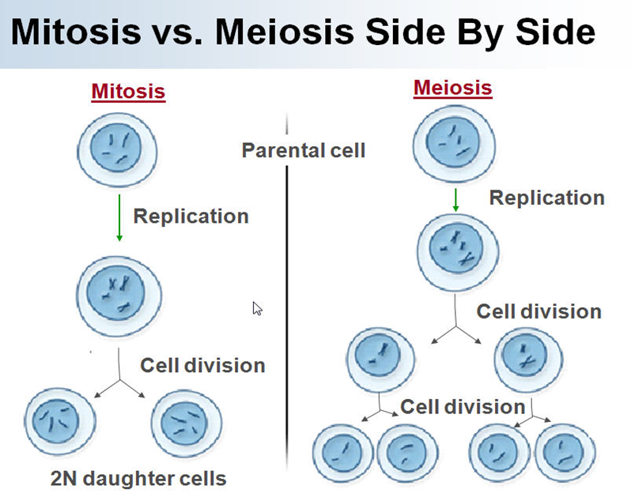
 | Mitosis | Meiosis
Number of cell divisions that take place | 1 | 2
Number of daughter cells produced | 2 | 4
Number of chromosomes in daughter cells (for any organism) | same as parent cell | ½ the number as parent cell
Number of chromosomes in daughter cells in humans | 46 | 23
Occurs in this type of cells | body cells | sex cells(sperm and egg)
Purpose of this type of cell division | repair and growth | reproduction

