A. 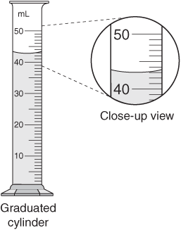B.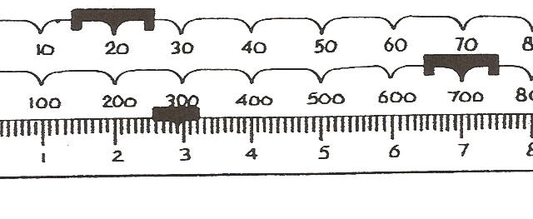

C. 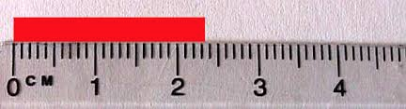

D. 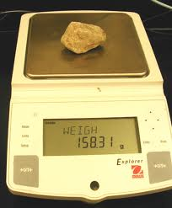 E. 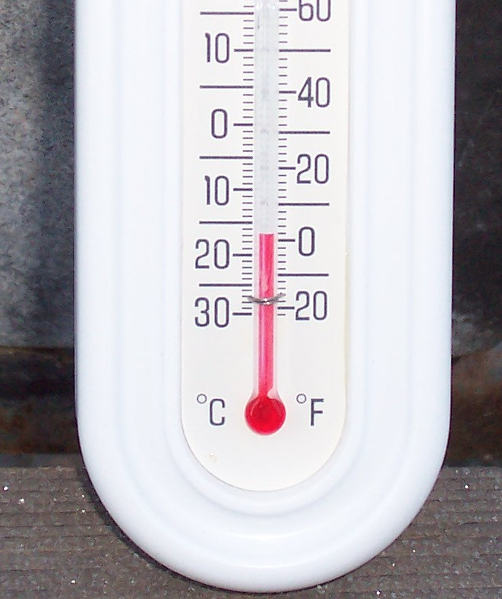

A. http://chemwiki.ucdavis.edu/@api/deki/files/426/20graphicaa.gif?revision=1 B. http://science.halleyhosting.com/sci/ibbio/inquiry/error/ruler2.jpg
C. http://tksmith.iweb.bsu.edu/EDTEC660/images/mass_tbb_quiz.jpg
D. .http://people.sinclair.edu/shanhuang/FLC/Density%20and%20Composition%20of%20Eros/LimestoneMass.JPG

