Animal Notes
Objective: Distinguish between the main animal phyla.
The Animal kingdom is in domain Eukarya

Characteristics:
- eukaryotic cells - have a nucleus
- multicellular - made of more than one cell
- heterotrophic - have to consume their food from outside sources
- no cell walls - only cell membranes surround cells
- usually reproduce by sexual reproduction
- develop from embryo - organism at earliest stage of development
- specialized parts (different tissues)
- can move (some don’t move much)

Animal Phyla:
cnidarians  - invertebrates no backbone  - radial symmetry  - have stinging cells  - have complex tissues, gut, nervous system  - examples: hydras, sea anemones, corals, jellyfish | 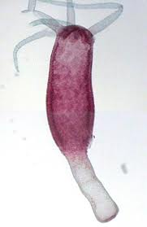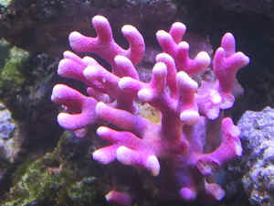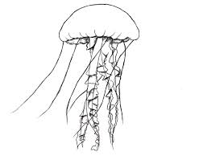
mollusks  - invertebrates  - bilateral symmetry  - has soft body, usually covered by a hard shell  - have circulatory system and gut  - examples: slugs, snails, clams, squids, octopuses | 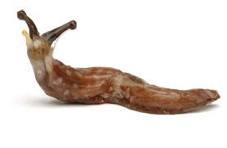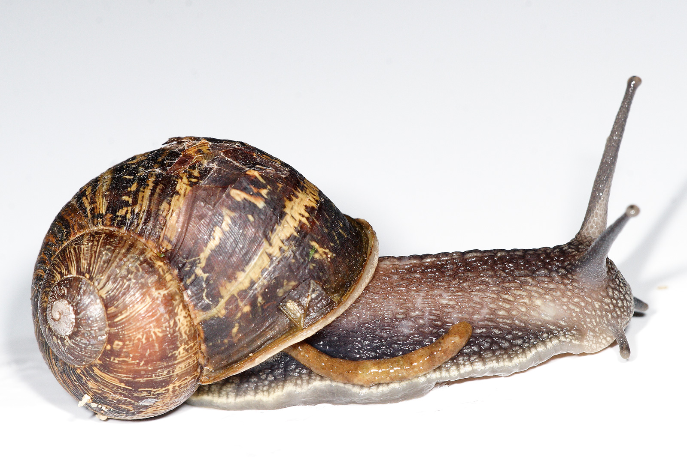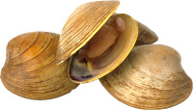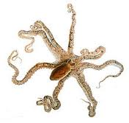
annelids  - also called “segmented worms”  - invertebrates  - bilateral symmetry  - has gut, circulatory system, nervous system  - examples: earthworms, bristle worms, leeches | 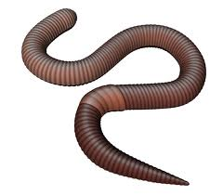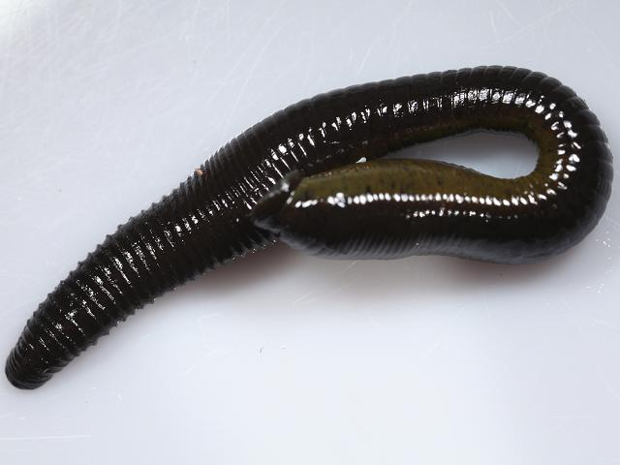
arthropods  - invertebrates  - bilateral symmetry  - jointed limbs, segmented body (head, thorax, abdomen)  - exoskeleton - external skeleton made of protein & chitin  - largest group of animals on Earth  - examples: insects, spiders, scorpions, ticks, crabs, barnacles, lobsters, centipedes | 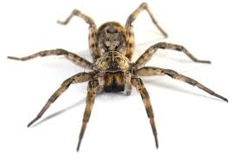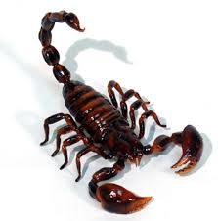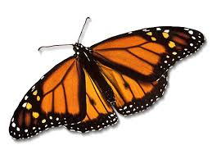
echinoderms  - invertebrates  - bilateral or mostly radial symmetry  - live in marine habitat  - endoskeleton - internal skeleton  - examples: starfish, sea urchins, sand dollars | 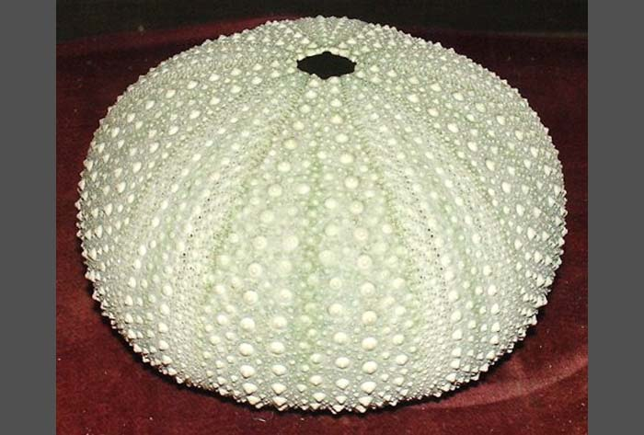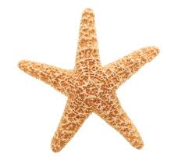
chordates  - vertebrates - have a skull and backbone  - notocord (later replaced by backbone), hollow nerve cord  - bilateral symmetry  - examples: fish, amphibians, reptiles, birds, mammals | 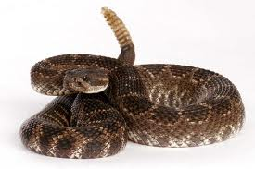

Summary: Using complete sentences, describe the seven main groups of animals.

Name: _________________________________Date:_________ Block_________ NB Page:___
Animal Notes: Objective: Distinguish between the main animal phyla.
The Animal kingdom is in domain _________________________

Characteristics:
- _________________________cells - have a nucleus
- _________________________- made of more than one cell
- _________________________- have to consume their food from outside sources
- no _________________________ - only cell membranes surround cells
- usually reproduce by ________________________reproduction
- develop from embryo - organism at earliest stage of development
- specialized parts (__________________________)
- can move (______________________________________)

Animal Phyla:
cnidarians
- invertebrates

- _________________________symmetry

- have _________________________cells

- have complex tissues, gut, nervous system

- examples: __________________________________
mollusks
- invertebrates

- bilateral symmetry

- has soft body, usually covered by ______________

_______________________________________

- have circulatory system and gut

- examples: slugs, snails, clams, squids, octopuses
annelids
- also called “______________________________”

- invertebrates
- _________________________symmetry

- has gut, circulatory system, nervous system

- examples: __________________________________
arthropods
- invertebrates

- _______________________symmetry

- jointed limbs, segmented body (head, thorax, abdomen)
- _________________________- external skeleton made of protein & chitin

- ______________________group of animals on Earth

- examples: __________________________________

__________________________________________
echinoderms
- invertebrates

- bilateral or radial symmetry

- live in _________________________habitat

- _________________________- internal skeleton

- examples: __________________________________
chordates
- _________________________- have a skull and backbone

- notocord (later replaced by backbone), hollow nerve cord

- _________________________symmetry

- examples:________________________________

________________________________________

