Name: _______________________________ Date:________ Notebook p:____

Gregor Mendel (1822-1884)
In the mid-1800s, a young monk named Gregor
Mendel took care of a monastery garden in Czechoslovakia.
Mendel noticed that the pea plants growing in the garden
had a variety of characteristics. Some plants had tall stems.
Other plants had short stems. The seeds of some plants
were round; others were wrinkled. Mendel wondered what
caused the plants to have these different characteristics. 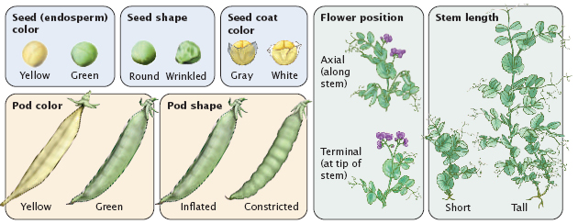
Mendel began to experiment with the pea plants. Because pea plants grow and reproduce quickly, Mendel was able to observe many generations of the pea plants. From his experiments, Mendel concluded that traits were passed from the parent plants to their offspring. The results of Mendel’s experiments were published in 1866. However, it was not until 1900 that scientists began to analyze Mendel’s research. Since that time, many new discoveries have been made about heredity. However, Mendel’s original hypothesis still forms the basis of modern genetics.

- Gregor Mendel was a young __________________ who lived in a monastery in ___________________________________.

- What did Mendel notice about the characteristics of the pea plants that he was growing in the garden?

- What did Mendel do with the pea plants?

- Why was Gregor Mendel able to observe many generations of pea plants?

- What did Mendel conclude from his experiments with pea plants?

- Why do you think Mendel is referred to as the “father of genetics”?

