Food webs

Objective: Analyze how energy flows through an ecosystem.
Plants &  Algae  Animals, Fungi, Bacteria | Energy enters an ecosystem through the process of photosynthesis and is passed through the system as one organism eats and is, in turn, eaten.  Food chains are representations of how energy is passed.  The arrow points in the direction the energy moves.  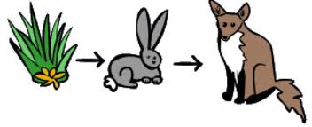  Producers  - perform photosynthesis  - basis of food webs  - examples: grass, algae, trees  Consumers  - obtain energy by eating other organisms  - some consumers hunt (predators) other consumers for food (prey)  - examples: rabbit, eagle  Decomposers  - break down dead organisms  - examples: fungi, bacteria, worms, flies  Food webs are more realistic representations about how energy passes through an ecosystem.
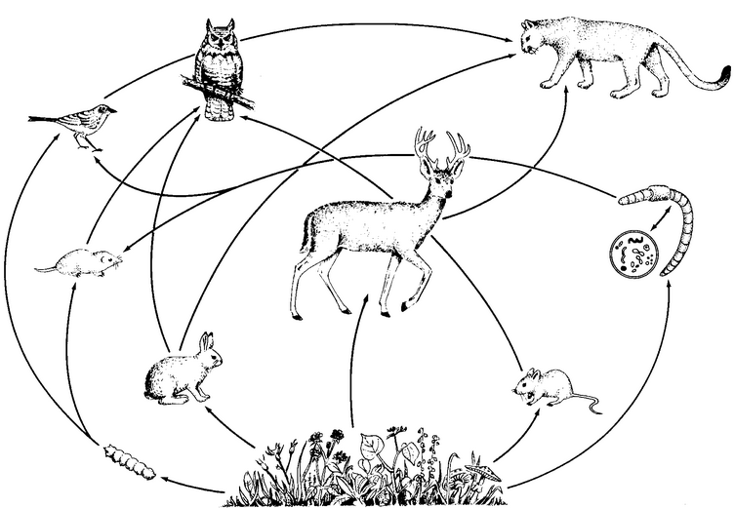
Summary: How does energy flow through ecosystems? Use the vocabulary words from the notes in your answer. Write in sentences!

