Energy pyramids
Objective: Analyze how energy flows through an ecosystem.
Types of Consumers
Herbivores - eat only plants
Carnivores - eat only animals
Omnivores - eat plants & animals
Scavengers - eat dead animals

Energy Pyramids
The trophic levels are:
- Producer – performs photosynthesis. Ex: plant
- first-order consumer – eats producers. Ex: grasshopper
- second-order consumer – eats first-order consumers. Ex: bird
- third-order consumer – eats second-order consumers. Ex: hawk

This can be modeled through an energy pyramid, in which the producers provide the broad base that supports the other interactions in the system.
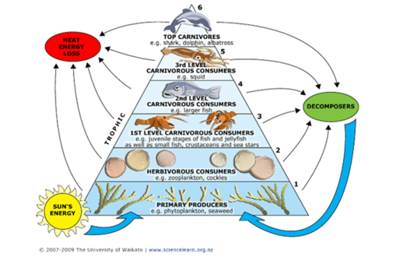
The amount of energy available to each successive trophic level decreases by 10%
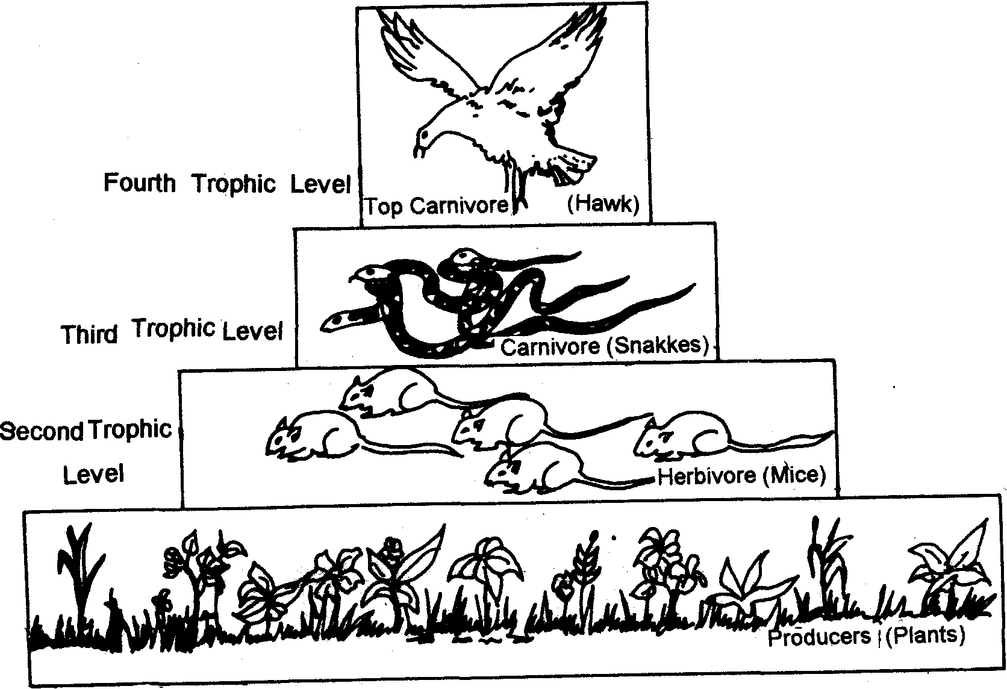
Population size decreases as the amount of energy available to the trophic level decreases.

An organism’s niche is the role it plays in an ecosystem.

Summary: Give a food chain and its corresponding energy pyramid. Which population would have the most available energy? Which population would have the greatest population size?

