Ecology is the study of organisms and their environment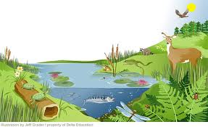
Biotic factors are living (or were once alive)
Examples: deer, hawk, fish

Abiotic factors are nonliving
Examples: soil, air, water

Organism - a living thing
Example: a bacterium, a tree, a frog, a dragonfly

Population - a group of living things (all the same species) in an area
Example: all the white-tailed deer in a park

Community - a group of living things in the same area
Example: all the organisms in a park

Ecosystem - a group of living and nonliving things in the same area
Example: the park and all things in it
Summary: Using complete sentences, explain how the bold vocabulary words are related.

