Meiosis
Objective: Describe the purpose and outcome of meiosis.
The purpose of meiosis is to produce reproductive (sex) cells that carry half the genetic material (DNA) of the parent cell.
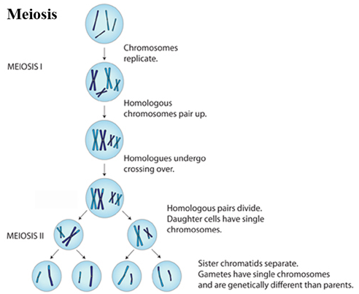
The result of meiosis is 4 reproductive cells (sperm or egg) that are genetically different.

