Name_____________________________________ Date________ Block_____

Cell Analogies: Can you compare the picture with the function of a cell organelle?
Use your vocabulary list to figure out these analogies. Fill in the blank with the appropriate cell organelle. Bonus: Draw a picture of the organelle.

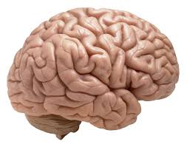* | The nucleus is like a brain because it controls all activity that organisms perform.
* | The cytoplasm is like jello because it is thick enough to hold things in place inside of a container.
* | The cell membrane is like a cellophane bag because it holds the contents l and can let things in and out
 | The vacuole is like a bottle because it can store water until needed to quench thirst.
* | The cell wall is like a brick wall because it gives strength and support.
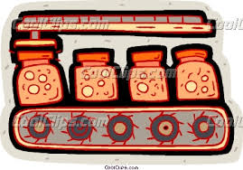* | The Endoplasmic reticulum(ER) is like an assembly line conveyor belt because it breaks down and packages proteins for delivery.
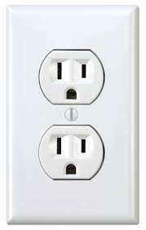* | The mitochondrion is like an outlet because it provides energy.
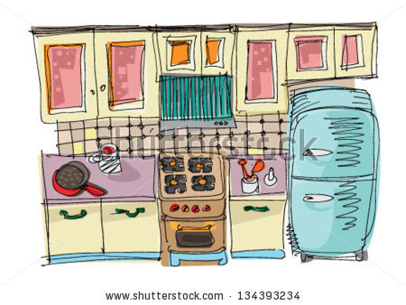* | The chloroplast is like a kitchen because that’s where food is made.
* | The chlorophyll is like a chef because it captures the ingredients to make its own food.

