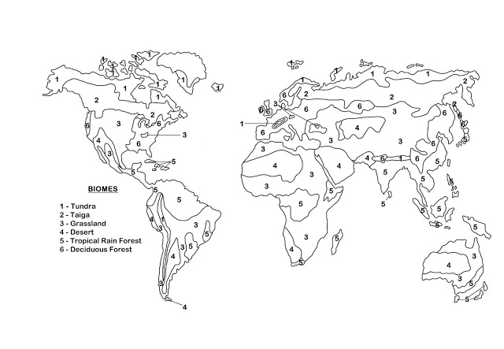

Biome Map Coloring
Color the map according to the clues listed below. You may need to look at a map of North America if you get stuck. Place a check mark in the box once you have completed that step.
1. The dotted lines represent the border between the U.S. and Mexico and Canada. All other lines show biome borders. Color the U.S. borders (dotted line) red.
2. Northern Canada and Alaska are tundra - color the tundra light blue
3. Most of Canada is boreal forest. Color the boreal forest dark green.
4. The west coast of the U.S. is mainly Temperate forest where California is. The east coast, all the way to the center of the country is also Temperate forest. Color the Temperate forest light green.
5. The Midwest (middle of the country) is temperate grassland. Color the grassland yellow.
6. The eastern edge of Mexico and Central America, Hawaii, and the Caribbean Islands are all tropical rain forests. Color those purple.
7. There is a northwest coniferous forest located in the far corner of the U.S (northwest). Color the northwest coniferous forest brown.
7. The great lakes and the lakes in Canada are freshwater. Find each freshwater lake and color it pink.
8. The bodies of water surrounding the continent are salt water. Color the coastal areas dark blue.
9. The western region of the U.S. as well as Northern Mexico is desert. Color the desert orange.
10. The western edge of Mexico is temperate forest. Color it the same color as you did the other temperate forests.
11. Color code the squares at the bottom to match your biome colors.
12. Label the countries: U.S.A., Canada, Mexico
