Notes: Traits Name: __________________________ Notebook p. ____
Objective: Distinguish between acquired and inherited traits.
Have you ever heard the expression. “you have your mother’s eyes”? Or “you have your father’s walk”? This phenomenon is not only true with people...but with animals and plants as well.
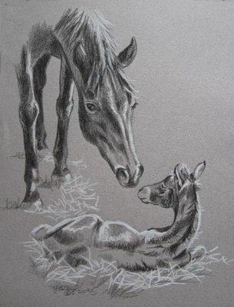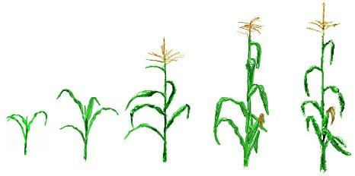
Things like skin color, fur color, and the shape of a leaf are all characteristics or traits.

A trait is a characteristic of a living thing. Traits can be:
- inherited traits - characteristics one is born with. They are passed on genetically from parents to offspring.
examples: height, natural hair color, bone structure, etc.

- acquired traits - obtained during the course of a person’s lifetime, including learned behaviors and contagious diseases
examples: the ability to play piano, getting chicken pox, dying your hair lime green, etc.

Decide whether the traits below are inherited or acquired.
- The shape of your nose inherited
- The length of your toes inherited
- Ability to hit a baseball acquired
- The extent of your vocabulary acquired
- Your shoe size inherited
- Eye color inherited

These mice are siblings. Why do you think that they are different colors?

Simple traits have two alleles (or versions).
Dominant allele
Recessive allele

Dominant traits usually show up more frequently during genetics experiments. What color do you think is dominant in the mice? Darker fur

Other examples of dominant traits:
Brown hair, brown eyes, having a widow’s peak, having earlobes that are unattached and “dangly”, dimples

Recessive traits usually show up less frequently during genetics experiments. What color do you think is recessive in the mice? White fur

Other examples of recessive traits:
Red hair, blue eyes, having no widow’s peak, having earlobes that are attached, no dimples
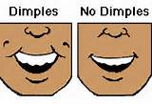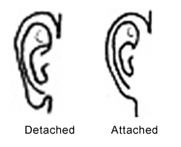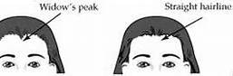

Summary: Using complete sentences, describe three inherited and three acquired traits as they appear throughout your family or a family of someone you know.
Inherited Traits | Acquired Traits

Notes: Traits Name: __________________________ Notebook p. ____
Objective: Distinguish between acquired and inherited traits.
Have you ever heard the expression. “you have your mother’s eyes”? Or “you have your father’s walk”? This phenomenon is not only true with people...but with animals and plants as well.
Things like skin color, fur color, and the shape of a leaf are all ____________________or ____________.

A ____________is a characteristic of a living thing. Traits can be:
- _____________________traits - characteristics one is ______with. They are passed on __________________from ____________to __________________.

examples: ______________________________________________

______________________________________________________

- ______________________________ traits - _____________during the course of a person’s ____________, including ______________ ________________and contagious ____________

examples: ______________________________________________

______________________________________________________

Decide whether the traits below are inherited or acquired.
- The shape of your nose ________________
- The length of your toes ________________
- Ability to hit a baseball ________________
- The extent of your vocabulary ________________
- Your shoe size ________________
- Eye color ________________

These mice are siblings. Why do you think that they are different colors?

Simple traits have two ________________ (or ________________).
Dominant allele
Recessive allele

________________traits ___________show up more ________________during genetics experiments. What color do you think is dominant in the mice? _______________

Other examples of dominant traits:
______________________________________________________

______________________________________________________

________________traits usually show up _______ _______________ during genetics experiments. What color do you think is recessive in the mice? _____________

Other examples of recessive traits:
______________________________________________________

______________________________________________________

Summary: Using complete sentences, describe three inherited and three acquired traits as they appear throughout your family or a family of someone you know.
Inherited Traits | Acquired Traits

