Enzyme Notes

1. What are Enzymes?

2. What are catalysts?

4. How do enzymes work?

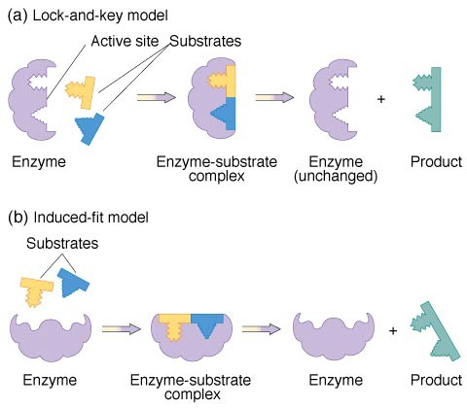

5. How many different types of reactions can one type of enzyme catalyze?

6. How do enzymes get their names?

- amylase:

- lactase:

c. pepsin:

7. Why are enzymes important?

8. What can go wrong with enzymes?

- Temperature:

- Too low:

- Too high

- pH:

*Buffers can help:

