Enzyme Notes

1. What are Enzymes?

Proteins that act as biological catalysts

2. What are catalysts?

Substances that help to “speed up” chemical reactions, but are not used up in
the reaction

4. How do enzymes work?

They lower the energy it takes for a chemical reaction to take place(activation energy)

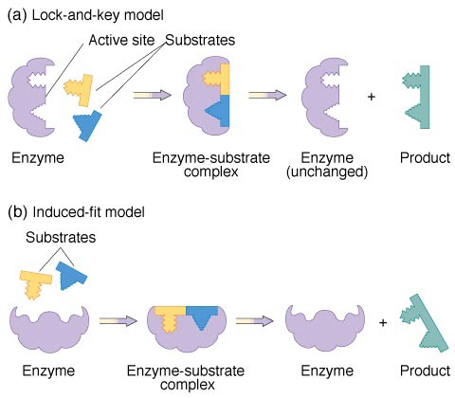

5. How many different types of reactions can one type of enzyme catalyze?

Each enzyme can be used over and over again, but only works on one
specific substrate.
6. How do enzymes get their names?

Most enzymes get their names from the substrate they interact with. Many
times the substrate name + “ase”

- amylase:

Breaks down starch called amylose. Enzyme found in saliva.

- lactase:

Breaks down lactose, the sugar found in milk.

c. pepsin:

Helps to break down(digest) proteins in stomach. Chemical bonds in
proteins are called peptide bonds.

7. Why are enzymes important?

Helps the cells effectively produce or break down molecules to form
substances they need.

8. What can go wrong with enzymes?

- Temperature:

- Too low:
Enzymes get rigid and don’t work effectively

- Too high

Enzymes denature(basically ”melt” out of shape like wax)
If temperature is too high, it is irreversibly changed

- pH:

enzyme will denature and not work

*Buffers can help:

Can add H+ ions if the solution is too basic, or absorb H+ if the
solution is too basic.

