Name:______________________________________________________ Date:________________ Period:________

#1-10: Determine if each statement below is TRUE or FALSE. If the statement is true, write
the word TRUE on the blank provided. If the statement is false, change the
underlined portion of the statement to make the statement true, and write your
changes on the provided blank.

______________________________ 1. Anton van Leeuwenhoek first named cells after the quarters
that monks lived in.
______________________________ 2. Simple cells with no nucleus or membrane bound
organelles are considered Prokaryotic.
______________________________ 3. Part of the cell theory states that all cells come from other
cells.
______________________________ 4. If enzymes are subjected to extreme temperatures or
extreme pH conditions, they will work more efficiently.
______________________________ 5. Only plants are made of cells.

______________________________ 6. Enzymes are complex carbohydrates that speed up
chemical reactions.
______________________________ 7. Bacteria are examples of eukaryotic cells.

______________________________ 8. The theory of evolution was developed as improvements in
microscopy occurred.
______________________________ 9. Theodor Schwann developed the theory that all plants are
made of cells.
_____________________________ 10. Enzymes can work on only 1 type of substrate, because of
their specific shapes.

#11-23: Label the indicated parts of the compound light microscope below.

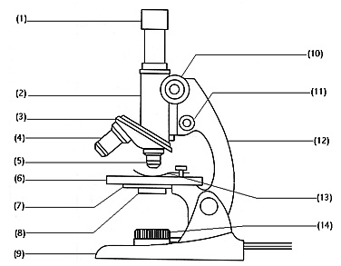

24. What are the total magnifications of the microscope above? A. _____________ B.____________

