Answers to cell Unit Test review Packet

II. Vocabulary

A. Eukaryotic K. cytolysis
B. Fluid-Mosaic model L. compound light
C. Robert Hooke M. endoplasmic reticulum
D. concentration gradient N. pinocytosis/phagocytosis
E. vacuoles O. mitochondria
F. hypertonic P. cell membrane
G. ribosomes Q. chloroplasts
H. prokaryotic R. nucleus
I. selectively permeable S. Shleiden/Schwann
J. centrioles

III. Short Answer

A. The invention and development of microscopes, especially the compound light
microscope, allowed scientists to discover and observe cells.

B. Eukaryotic and prokaryotic cells are similar, in that both contain DNA and have
cytoplasm. Eukaryotic cells are considered complex have membrane bound
organelles, including a nucleus. Prokaryotic cells are considered simple and
do not have membrane bound organelles or a nucleus. Bacteria are the only
organisms composed of prokaryotic cells, while animals, plants, algae, and
fungi are composed of eukaryotic cells.

C. Protein molecules embedded in the eukaryotic cell membrane function as
channels to carry particles across the cell membrane. They may also
function as the attachment site for carbohydrates markers. Carbohydrate
chains may be attached to proteins or lipids on the external surface of the
cell membrane. They act as markers for cell identification, and cell to cell
interactions.

D. Animal and plant cells are very similar, containing many of the same organelles
(nucleus, cytoplasm, mitochindria, etc). They differ, in that plant cells have a
rigid exterior organelle, the cell wall. Plant cells also contain a large central
vacuole for storing water and dissolved substances, as well as green
chlorplasts, where photosynthesis occurs. Animal cells contain centrioles, which are involved in cell division.

E. Passive transport involves the diffusion of particles across the cell membrane.
This means that particles travel from an area of high concentration to an area
of low concentration; the particles are said to be flowing down the
concentration gradient. thus, passive transport requires no energy by the
cell. In contrast, active transport is the passage of materials UP the concentration gradient(from an are of low concentration to an area of high concentration), and requires extra energy by the cell.

F. Hypertonic solutions have a HIGHER concentration of solutes than a cell.
Hypotonic solutions have a LOWER concentration of solutes than a cell.
Isotonic solutions have the SAME concentration of solutes as a cell.

G. Answers will vary: Example: cytoplasm is similar to blood because it circulates
around the cell and carries dissolved substances to all parts of the cell.

IV. Diagrams: Label each of the following diagrams.
Animal Cell Plant Cell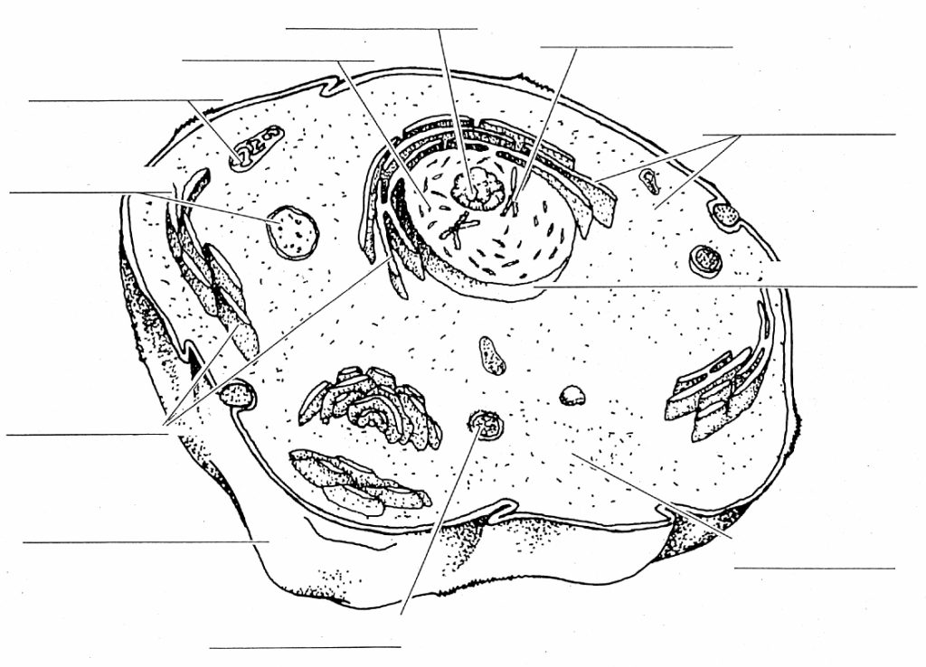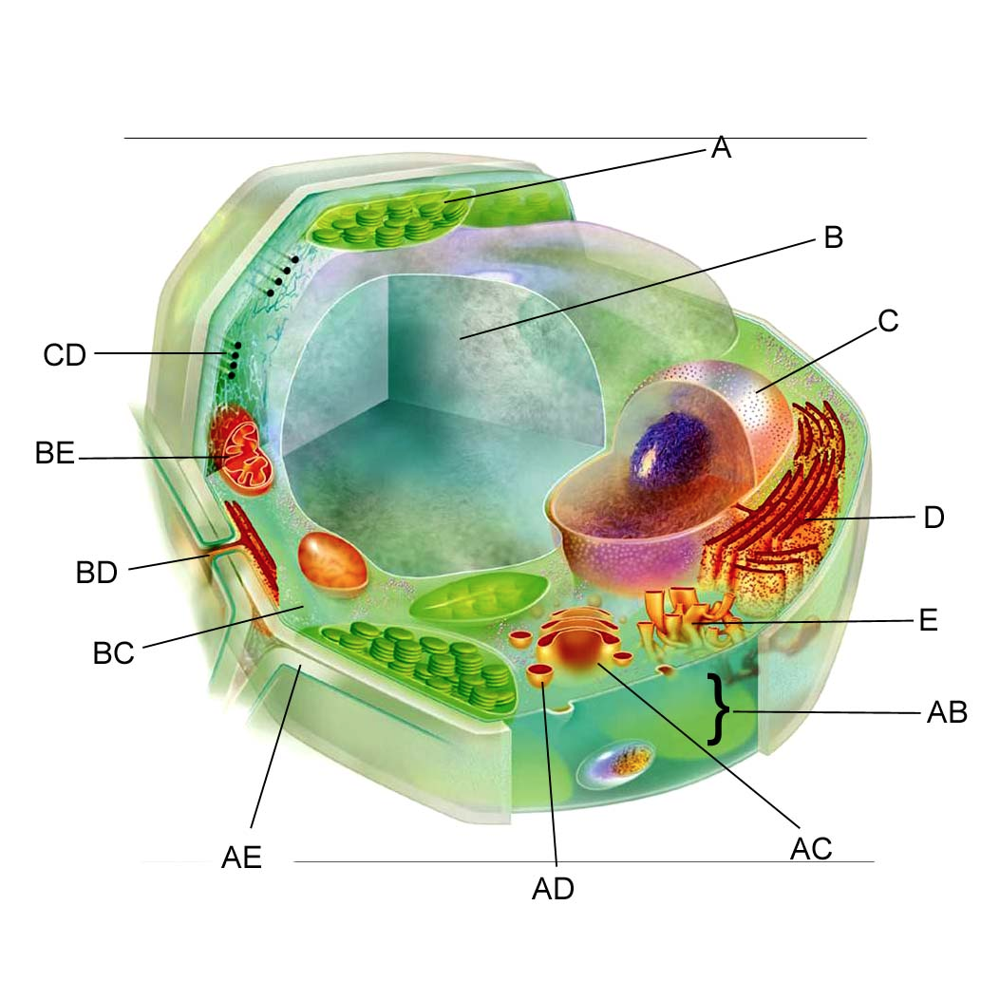
(clockwise starting at the top) A. chloroplast
Top 3 Nucleus B. vacuole
Ribosomes C. nucleus
Nuclear envelope D. rough endplasmic reticulum
cytoplasm E. smooth ER
lysosome AB. cell membrane
cell membrane AC. Golgi body
endoplasmic reticulum AD. vesicle
ER/vesicle AE. cell wall
mitochondria BC. cytoplasm
BD.
BE. mitochondria
CD. cytoskeleton

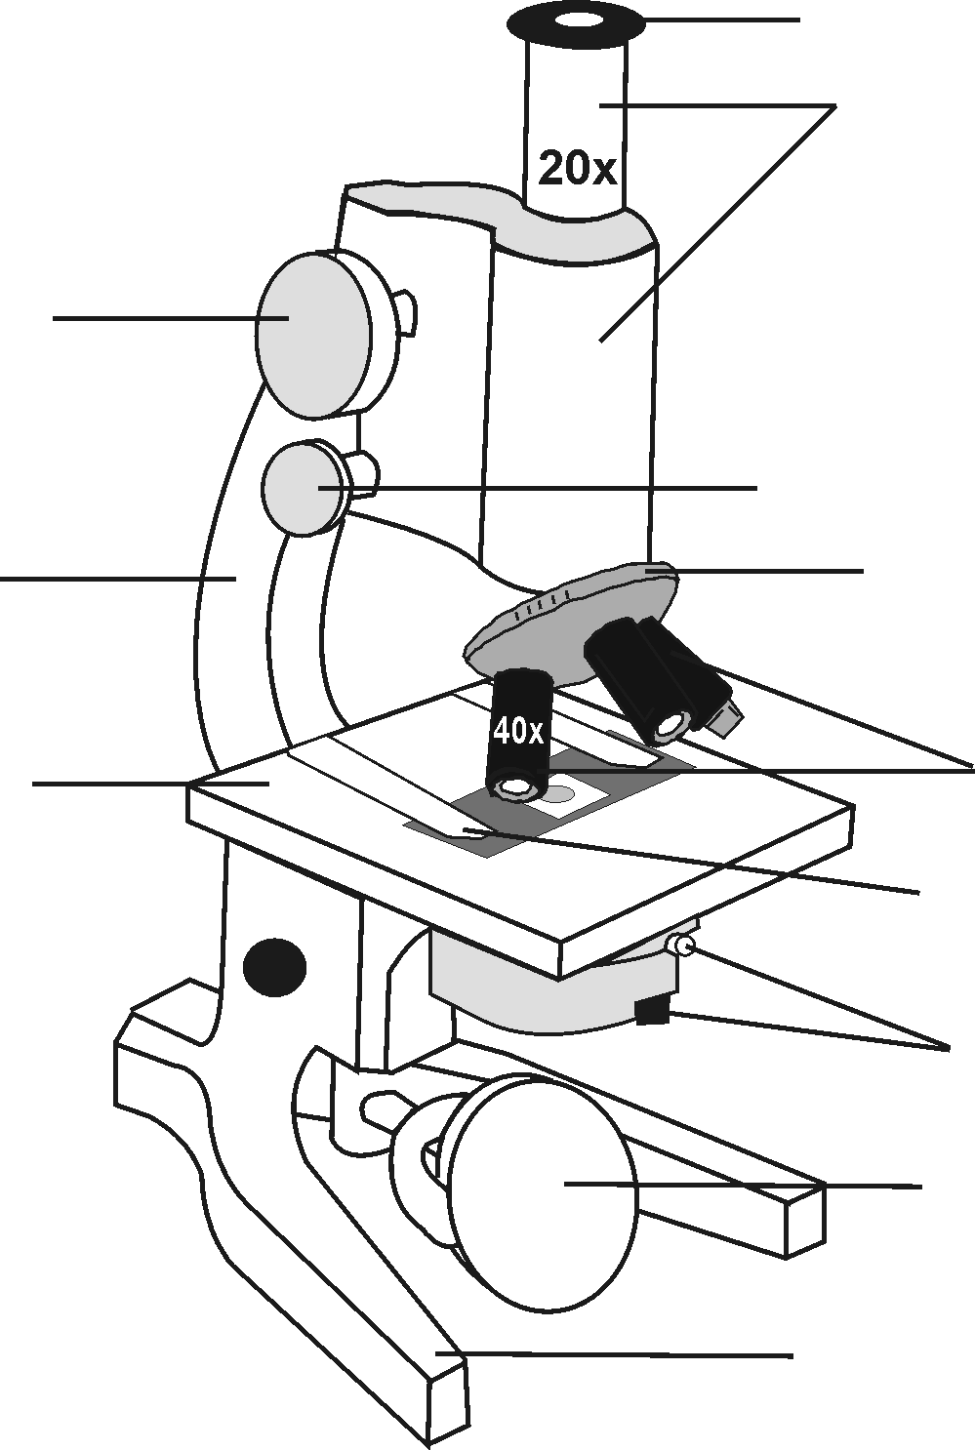What is the magnification of this microscope?80X
Microscope from top to bottom
eyepiece
body tube
coarse adjust
fine adjust
arm
revolving nosepiece
objective lenses
stage
stage clips
diaphragm
light source
base

hypotonic isotonic hypertonic
